**ALCOHOL DETECTION DEVICE**

**Introduction**

Drunk driving is a very dangerous behaviour . People become slow in reacting and can’t control their actions. Drunk drivers are not able to deal with the emergency situations when they are driving. The investigation done by the World Health Organization in 2008 shows that about 50%-60% of traffic accidents are related to drunk driving. The drunk driving has been listed as the main reason for the fatal car accident. These years, the cases of traffic accident caused by drunk driving have increased rapidly. More and more people have realized that the drunk driving does great harm to public security. It’s time to develop a kind of system which can stop the drunk driving effectively. As this kind of system hasn’t been popularized, we try to develop this system which is available on every car. The sensor can be fixed near the driver’s seat. The driver will breath to the system before he (she) starting the car. If the concentration of alcohol detected is below the allowable standard, the car can be started normally. If the concentration of alcohol is above the allowable standard, the system will send alarm to the driver. The main aim of this embedded application is to detect the alcohol drunken people. We are developing an embedded kit which will be placed in a vehicle. If any drunken person enter in to the vehicle it gives a buzzer sound immediately and the person gets notified whosoever is sitting inside the car so that they can take further steps for the betterment of that person and themselves.

**Why did we decide to make this project:**

This project was chosen for designing and executing the Alcohol detection using Arduino. Once the device is powered on by attaching to a power supply, the Arduino sketch starts running. It loads the required Arduino libraries and initializes LCD display. The Arduino starts detecting analog voltage from the sensor and converts it to a digital value using inbuilt Analog to Digital convertor. The reading is displayed on the LCD screen.

When police catch a suspect and test his breath, the MQ-3 sensor outputs a higher voltage at its analog output pin. After calibration, the level of alcohol beyond the legal limit is found to result in digitized reading beyond 600 ppm.

**Materials and methods**

Components Used:

* Hardware:

1. MQ3 Alcohol Sensor :

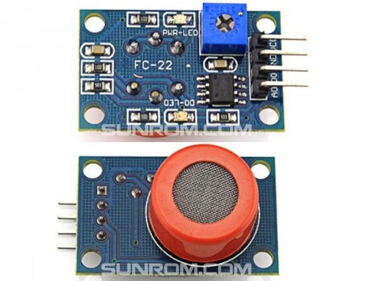

The analog gas sensor- MQ3 is suitable for alcohol detecting, this sensor can be used in a breath analyser . It has a high sensitivity to alcohol and small sensitivity to benzene. When the target alcohol gas exist, the sensor’sconductivity is higher along with the gas concentration rising, use of simple electro circuit, convert change of conductivity to correspond output signal of gas concentration.

1. Arduino UNO :

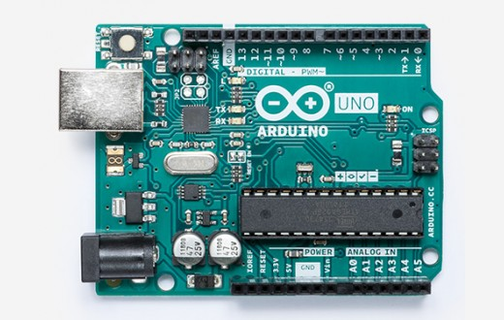

The Arduino board is the central unit of the system. The Arduino UNO is the microcontroller board based on the ATmega 328. It is a programmable microcontroller for prototyping electromechanical devices.

1. Piezo Buzzer :

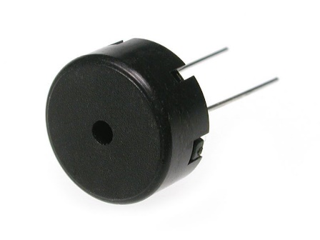

A buzzer or beeper is a signalling device, usually electronic, typically used in automobiles, household appliances such as a microwave oven, or game shows. It most commonly consists of a number of switches or sensors connected to a control unit that determines if and which button was pushed or a present time has lapsed, and usually illuminates a light on the appropriate button or control panel, and sounds a warning in the form of a continuous or intermittent buzzing or beeping sound.

LCD Display :

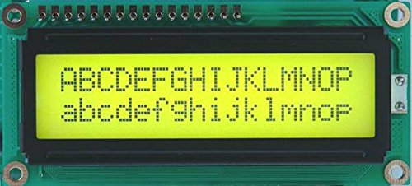

Liquid crystal display screen is the electronic display module and find a wide ranges of applications. A 16*2 LCD display is very basic module and it is very commonly use in various devices and circuit. These modules are preferred to seven segments and other multi segments LEDs.

1. Breadboard:

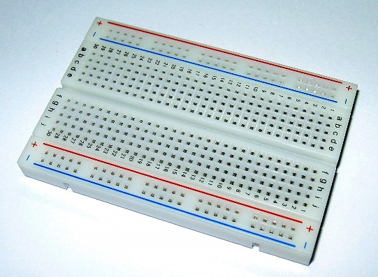

A **breadboard** is a solderless device for temporary prototype with electronics and test circuit designs. Most electronic components in electronic circuits can be interconnected by inserting their leads or terminals into the holes and then making connections through wires where appropriate.

**Mechanical Materials:**

1.Casing

2.MDF-sheet -5mm

3.Pipe of diameter 20mm and length 30mm is used.

4.Fevicol

* Software

1. Arduino IDE(Integrated Development Environment):

The Arduino**integrated development environment (IDE)** is a cross platform  application (for Windows, macOS, Linux) that is written in the programming language Java. It is used to write and upload programs to Arduino board.

The source code for the IDE is released by GNU General public Licence, version 2. The Arduino IDE supplies software library from the Wiring project, which provides many common input and output procedures.

2.Fritzing : Fritzing is an open source hardware initiative that makes electronics accessible as a creative material for anyone. It is a software tool and a community website for processing and Arduino ,fostering a creative ecosystem that allows users to document their prototypes, share them with others ,teach electronics in classroom, and layout and manufacture professional pcbs.

Methods

Circuit Designing:

Step 1:LCD is connected to Arduino .

Step 2:

1.9 volt battery is connected to arduino’s bin terminal.

2.Ground is connected to breadboard.

3. buzzer is connected to arduino’s B 3 pin.

4. Negative terminal of buzzer is connected to ground.

Step 3:1,5 and 16 are connected to ground.

2nd and 15th terminals are connected to 5 V pin of Arduino.

Step 4:4th pin is connected to D-12.

Step 5:3rd pin is connected to D-9 and 5th pin is connected to D-8.

Step 6:7th pin of LCD is connected to D-7.

Step 7:8th pin of LCD is connected to D-6.

Step 8:MQ 3 sensor is connected to A0 pin and ground pin is connected to ground. VCC oion is connected to 5V pin.

Software:

Step 1:Open Arduino IDE and copy the link.

Step 2:Open Arduino UNO in tools.

Step 3:Programmer used is AVRISP mkll

Step 4:Compile and upload it into Arduino IDE.

Step 5:If error is there it will get back to NOTE and then recheck.

**Schematics**

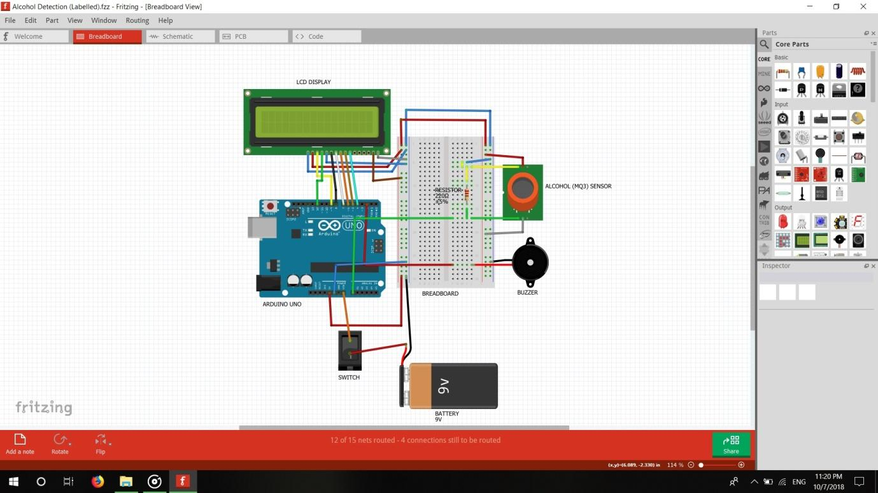

**Cad model**

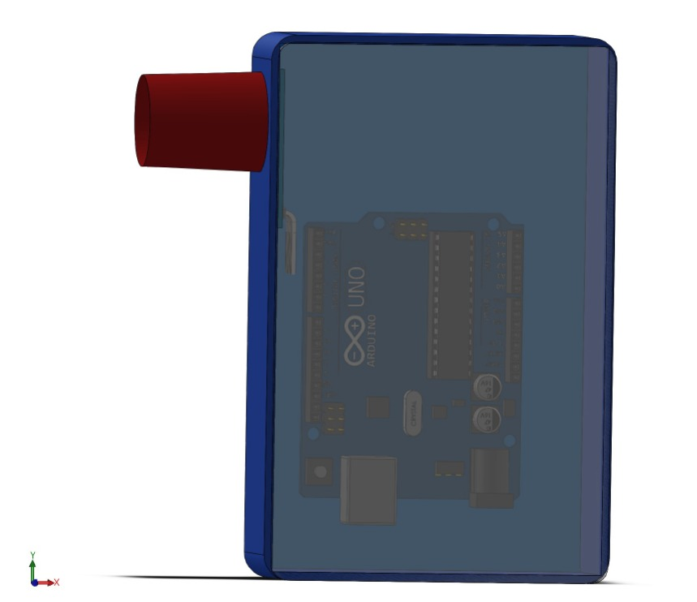

**Steps:**

1.Taking the base with dimension of 126.9mm*80mm in cad model.

2.Then making the base thicker with thickness of 30mm.

3.Then making of hole on 80mm side with the outer diameter of 20mm.

4.Then insert the pipe in that hole.

**Future scope**

1. Alcohol Detection System in Carscan provide an automatic safety system for cars and other vehicles as well if used along with an engine locking system.

2. Alcohol Detection System in Cars also helps in women safety.

3. It can help to decrease the number of accidents on the road and improve human safety.

4. Breathing analyser project can also be used in various companies or organization to detect alcohol consumption of employees.

5. The project can be further developed by including the drug detection or smoking detection applications.